Automobile Management System

# Description

Vehicle Management System is a AI system developed by implementing Bayesian network.

The system works alongside existing automobile engine management system and provide additional functionality and better system management for improved stability and longevity of the vehicle.

The developed solution can manage engine in normal condition and in crisis and its goal is to get maximum distance out that engine without destroying it in the process. The system will be cable of taking multiple aspects of an automobile such engine temperature, engine RPM, fan speed, available fuel before making decisions. This developed AI system will work in tandem with the existing automobile management system installed by the manufacturer.

Following is an overview of how system will integrate into the automobile system

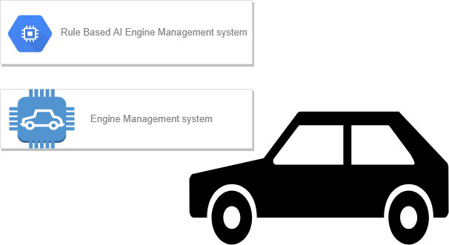

The Rule based AI engine management system is implemented to effectively manage resources to maximize the distance the car can do.

# Implementation

The system takes multiple aspects of the car into consideration before making decisions.

The nodes are divided into multiple categories to better represent their functionality

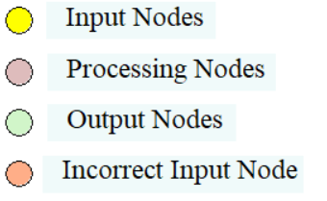

Input nodes are those nodes where system gets information of the automobile, it can either be manually entered by the user of the application or in most of the cases taken from sensors in the vehicle

Processing Nodes as name implies does the processing of the data which then can be used in decision making of the system

Output nodes represent the decision made by the system. These represent the probability of system change

Incorrect Input Nodes are preset to take incorrect sensor reading into consideration.

The main system health depends on multiple subsystem as described below. For exact nature of the dependency and how input is connected to rest of the system please refer to the individual table of each nodes.

### Oil System Health:

The Oil System Health depends on Oil Change Record-which represent the last time the oil was changed, Oil Level, Oil Temperature, and cooling Fan speed as descried below. Based on the input the health either would be good or bad.

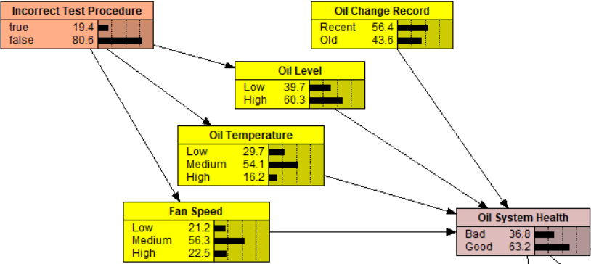

### Engine Health:

The Engine health depends on following input, the result would either be good or bad.

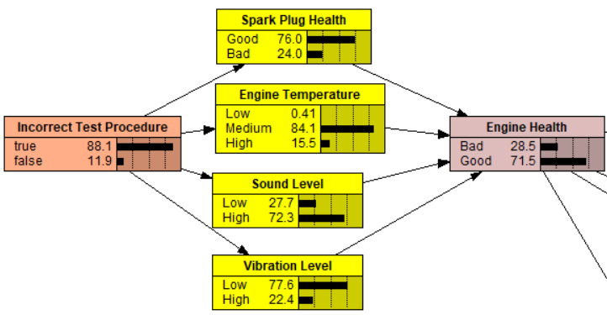

### Tire Health:

The Tire health take multiple input into consideration as shown below. In this case along with the tire health, recommendation for tire change is added which helps user in determining if it’s time for them to change the tire.

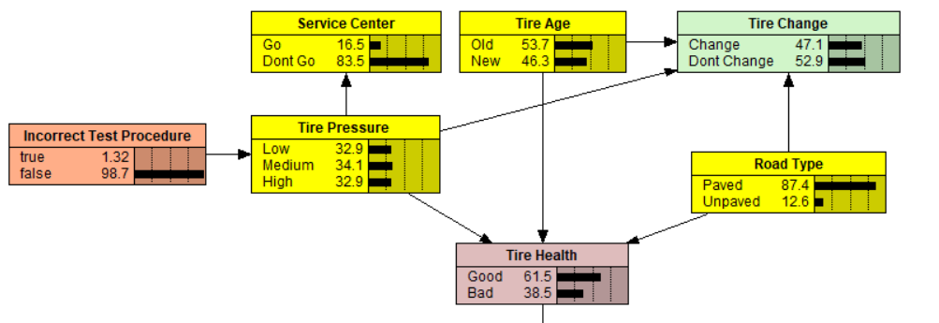

### Fuel Health:

Fuel health as shown below not only takes inputs to determine the overall fuel health but also determines the probability of user getting to next fuel station.

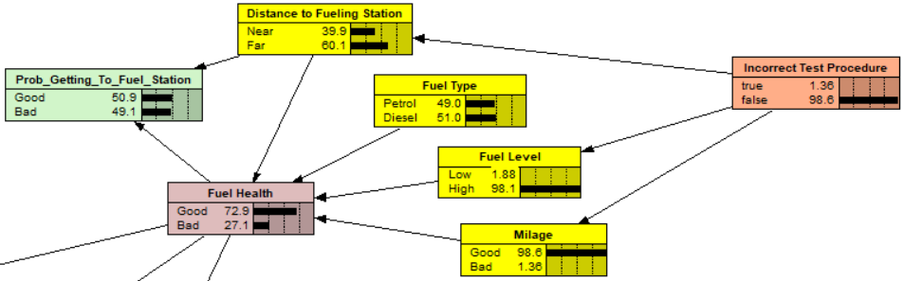

### Radiator Health and Weather:

Radiator health and weather outside are dependent on the Outside Temperature along with other factors as shown

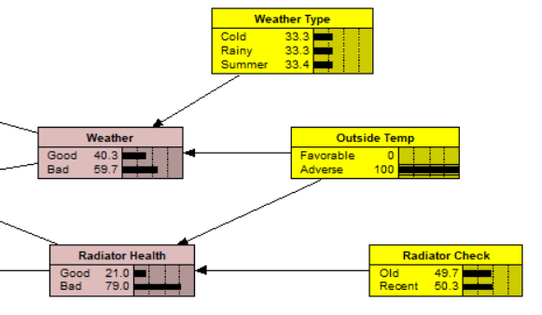

### System Health:

The overall system health is determined by all the above subsystem health. This shown how good or bad condition automobile is. Majority of the decision are based on this factor. Please refer to the table of the system health for exact dependency on the subsystem.

### Output Nodes:

Output nodes are those nodes which represent the changes that are done on the vehicle or recommended changes.

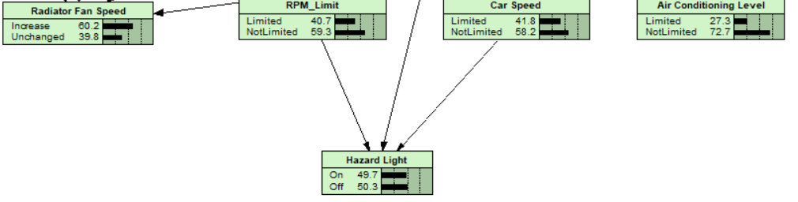

# Testing

Based on the previous suggestions provided by the evaluator, the documentation part been further updated. Assuming you have the licensed Netica software, please open this file and compile. To try different input and see how system reacts just change the value on the slide.

Please feel free to play around with the system by entering the custom values that you would like to try.

-Boyka